GAME NAME  
Cross Platform Development

Author: <Justin / Igor>

Abstract

Top-down zombie shoot em up.

# Change Log

Updates made to the document should be described below.

|  |  |  |  |
| --- | --- | --- | --- |
| Version | Author | Date of change | Description |
| 0.0.0 | AIE | 31/08/2020 | Initial Template created |
| 0.0.1 | Igor, Justin | 04/09/2020 | Implemented initial documentation design choices for game. Ideal controls and struggles and processes we may face dealing with cross platform development |
| 0.0.2 | Igor, Justin | 09/09/2020 | Updated doc to represent new arena in game  Updated doc to include wireframes of menus screens we wished to implement.  Updated feedback from meetings |
| 0.0.3 | Igor, Justin | 10/09/2020 | Updated feedback from meetings |
| 1.0.0 | Igor,Justin | 17/09/2020 | Added pause menu wireframe  Updated feedback from meetings |

Contents

Change Log 1

1.0 Development Environment 3

1.1 Game Engine 3

1.2 Source Control 3

1.3 Third-Party Libraries / assets 3

2.0 Game Overview 3

2.1 Genre 3

2.2 Camera Perspective and Movement 3

2.3 Platform 3

2.4 Technical Goals 4

2.5 Game Objects and Logic 4

3.0 Controls 4

3.1 Windows / Web 4

3.2 Console / Xbox 4

3.1 Android / Touch 4

4.0 Mechanics 4

5.0 Graphics 5

6.0 Audio 5

7.0 Artificial Intelligence 5

8.0 Game Flow 5

8.1 ‘Mission’ / ‘Level’ structure 5

8.2 Objectives/Goal 5

11.0 Interface 5

11.1 Menu 5

11.2 High scores 5

11.3 UI/HUD 5

12.0 Progress report and feedback Meeting Minutes 6

Friday 4th September 6

Wednesday 9th September 6

Thursday 10th September 6

Friday 11th September 7

# Development Environment

## Game Engine

Unity 2019.3.6.f1

Chosen Unity due to its ease of access and beginner friendly interface. The version chosen was selected to the version being constant among all computers on campus.

## Source Control

Link to GitHub repo: <https://github.com/JustinKatic/CPD-TopDownShooter>

## Third-Party Libraries / assets

|  |  |  |
| --- | --- | --- |
| Asset Name  License | URL | Reason for use |
| Character Pack: Zombie Sample  Free – Unity Extension Asset | <https://assetstore.unity.com/packages/3d/characters/humanoids/fantasy/character-pack-zombie-sample-131604> | Enemy asset use for enemy entities in game |
| Jammo Character | Mix and Jam  Free – Unity Extension Asset | [https://assetstore.unity.com/packages/3d/characters/jammo-character-mix-and-jam-158456#reviews](https://assetstore.unity.com/packages/3d/characters/jammo-character-mix-and-jam-158456%23reviews) | Character asset use for main player in game. |
| Weapon Master-Sci-Fi Weapon.1 Lite  Free – Unity Extension Asset | <https://assetstore.unity.com/packages/3d/props/weapons/weapon-master-scifi-weapon-1-lite-134423> | Character’s weapon asset |
| Glossy Bubbles  Free – Unity Extension Asset | <https://assetstore.unity.com/packages/2d/gui/icons/glossy-bubbles-114601> | Bullets |
| Dungeon - Low Poly Toon Battle Arena / Tower Defense Pack  Free – Unity Extension Asset | <https://assetstore.unity.com/packages/3d/environments/dungeons/dungeon-low-poly-toon-battle-arena-tower-defense-pack-109791> | Game Arena |
| ArcadeMusicLoop.wav  <https://creativecommons.org/licenses/by/3.0/> | <https://freesound.org/people/joshuaempyre/sounds/251461/> | Game scene background music |
| Potions, Coins And Box Of Pandora Pack  Free – Unity Extension Asset | <https://assetstore.unity.com/packages/3d/props/potions-coin-and-box-of-pandora-pack-71778> | Health Potion asset |
|  |  |  |
|  |  |  |
|  |  |  |
|  |  |  |
|  |  |  |
|  |  |  |

# Game Overview

Top down zombie shoot em up.

## Genre

3D Top down Shooter

## Camera Perspective and Movement

Top Down Camera Perspective with rigid body velocity movement

## Platform

PC–Unity pc builds

Android– Unity Android build, as well as correct SDK paths,

Web–GitHub setup, chrome, or Firefox

Xbox– correct unity builds installed for Xbox

## Technical Goals

* Screen resolution works for all devices of all sizes
* Controls work across multiple input devices including phone, pc and Xbox
* Game builds on phone, pc, and Xbox

## Game Objects and Logic

Android – Controlled by the player.

Zombie – Walks towards the player.

Gun – Used by the player to shoot zombies.

Shotgun – Weapon powerup dropped by the boss zombie and collected by the player. Increases player firepower.

Health pack – Fills the players health. Dropped by big green zombie upon death.

# Controls

## 3.1 Windows / Web

**Keyboard**

W - Move Player Character forward.

A - Move Player Character left.

S - Move Player Character backwards.

D - Move Player Character right.

**Mouse**

Left Click - Shoot bullet.

Mouse movement - Rotate player to face towards mouse position.

## 3.2 Console / Xbox / PS4

**PS4 / Xbox analog sticks**

Left analog stick - Move player character in direction of left analog stick.

Right analog stick - Rotate player to face in direction of right analog stick.

- Shoot in direction right analog stick is facing.

## 3.1 Android / Touch

**Android joysticks**

Left Joystick - Move player character in direction of left joystick.

Right Joystick - Rotate player to face in direction of right joystick.

- Shoot in direction right joystick is facing.

# Mechanics

* **Shooting**

Shooting in game creates a satisfying element to the game blasting away all zombies in site.

* **Survival**

Player health gives the player a sense of survival and creates strategy to survive.

* **High score**

Giving an objective for the player creates a sense of accomplishment and a desire to beat a previous high score.

* **Endless zombies**

Creates a sense of you are never safe you must always be running to stay ahead of the approaching zombies.

## Hazards

Throughout the map there are castles placed which is an indication of where the enemy spawn points are.

## Obstacles

To Progress to next wave, you need to destroy all the big zombies in each wave however there are lots in mini zombies that may get in your way trying to attack the player. This creates the gameplay of the player always needing to be on the move repositioning and having to shoot through hordes of little zombies to get to the big zombie

## Items / Collectables

Shotgun – When a boss zombie is killed, it will drop the shotgun which can be collected by the player. The player’s firepower will be increased from one stream of bullets to five. This will allow the player to better cope with the increased number of zombies.

Health Pack – When a big green zombie is killed, it will drop a health pack. Collecting this will fill the player’s health.

Power up – when a power up zombie is killed it will drop a power up item, collecting this will add 2 extra bullets to the player for a short time which have a more confined shoot angle allowing to better focus big zombies down quickly.

# Graphics

The game is a top-down shooter with 3D graphics.

The art style for the arena is low poly.

A low poly art style for arena was chosen to allow for better performance in other areas due to the low graphical footprint. This is especially important when it came to our mobile platform.

# Audio

Background music is a 16-bit retro arcade type tune. On top of that a Zombie growling sound

# Artificial Intelligence

Zombies simply walk towards the player. They have no other behavior.

However, each zombie has different attribute values for health and speed, as well as varying in sized to distinguish which zombies are which and how they behave.

Small zombie – 1 hp low move speed

Medium zombie – 20 hp low move speed

Red zombie – 1 hp fast move speed

Giant zombie / Health zombie – 50 hp medium move speed

Boss zombie – 300 hp high move speed

# Game Flow

## ‘Mission’ / ‘Level’ structure

There is only one level.

However, high scores are saved to the device.

## Objectives/Goal

The players objective in each wave is to kill all the big zombies while avoid being killed themselves. Killing all the big zombies results in the next wave beginning. The goal is to try and get to the highest wave possible.

1. Levels

There is one level. It is an open arena in the shape of a square which is bounded by walls on each side. The player can move anywhere on the level, except past the walls. There are no obstacles.

# Interface

## Menu

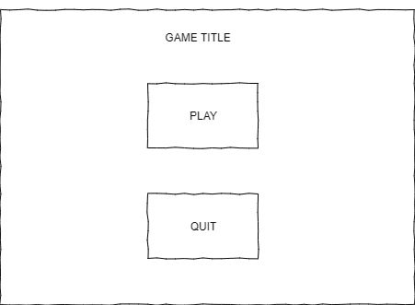

All menu buttons and pause screen buttons are navigable over each device we plan to release for.

Windows – mouse click the button or use ‘W’ and ‘S’ to highlight button and “Enter” to select.

X Box – Left joystick up and down to highlight button and ‘A’ to select.

Android – Tap on screen button to select.

## High scores

The current high score is shown in game under the current score. It’s also displayed again in the Game over screen.

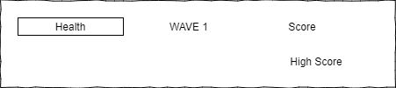

## UI/HUD

Windows, Web and XBOX UI:

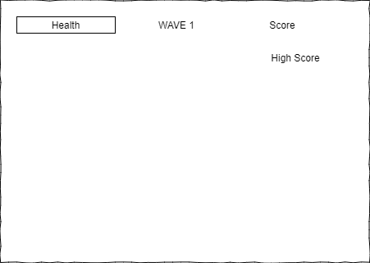

Android UI: Virtual pause button and virtual joysticks present on Android.

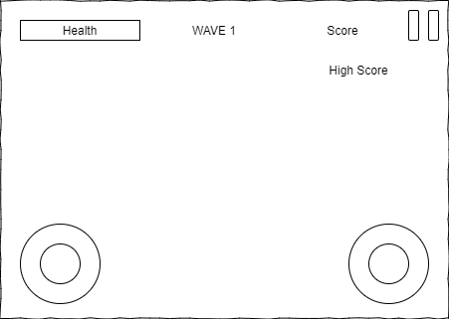

Game over UI:

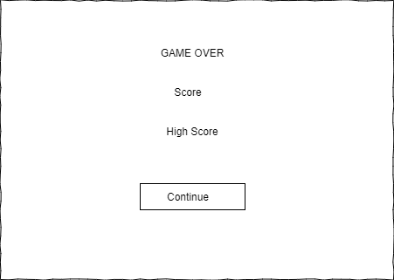

Pause menu UI:

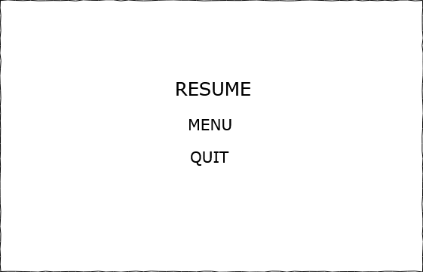

# Progress report and feedback Meeting Minutes

## Friday 4th September

Describe state of project

* Basic game implemented. Player can move around the arena and shoot zombies.
* Player can pick up shotgun weapon and health pack.
* Can play on web, android, and windows.

Feedback from teacher and peers:

* Remove quit button on mobile and web
* Fix scale of objects
* Fix health bar scaling
* Fix flying zombies

Action Items:

* Objects have been scaled
* Health bar filter mode changed to Point

## Wednesday 9th September

Describe state of project

* Basic game implemented. Player can move around the arena and shoot zombies.
* Player can pick up shotgun weapon and health pack.
* Can play on web, android, and windows.
* High scores now saving

Feedback from teacher and peers:

* Fix inverted web controls.
* Remove quit button on web

Action Items:

* Web controls fixed.
* Web button removed.

## Thursday 10th September

Describe state of project

* Same as on 9th of September.

Feedback from teacher and peers:

* Zombie damage indication.

Action Items:

* Zombie blood effect on bullet hit.

## Friday 11th September

Describe what has been done since last time

* Changed text to use Text Mesh Pro.
* Changed boss wave text.
* Added new skybox.
* Added crosshair.
* Increased player health.
* Added physics material to player to prevent getting stuck inzombie crowd.
* Added light to health pack.
* Changed virtual joystick position and alpha.

Feedback from teacher and peers:

* Menu resume button looks like a heading instead of part of the menu.

Action Items:

* Reduce text size of resume button in pause menu.